# A2: LearnIt - User Interface Prototype

This user interfaces prototype (or horizontal prototype) has the following goals:

1. Help to identify and describe the user requirements, and raise new ones;
2. Preview and empirically test the user interface of the product to be developed;
3. Enable quick and multiple iterations on the design of the user interface.

This artefact includes three elements:

1. Overview of the interface elements and features common to all pages;
2. Overview of the information system from the viewpoint of the users (sitemap); and
3. Identification and description of the main interactions with the system, organized as sequences of screens (storyboards).

The interface's descriptions are presented on the end of the document.

## Interface and common features

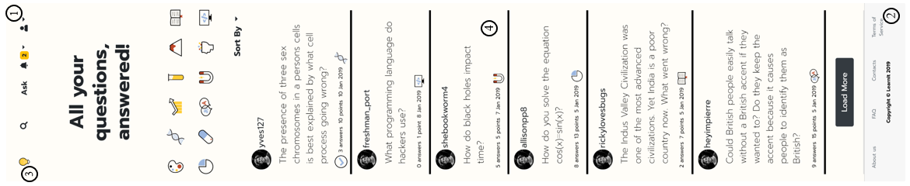**LearnIt** is a web application based on HTML5, JavaScript and CSS. The user interface was implemented using the Bootstrap framework (version 4.0). This framework simplifies the development of fluid layouts capable of adapting to various devices as the responsive part is already built in.

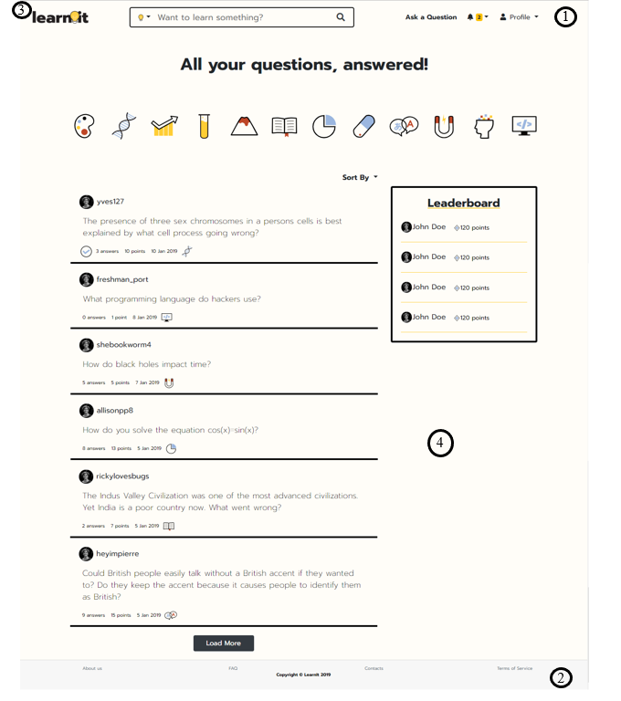

**Fig 1.** Interface's guidelines.

**1 – Navbar.**

**2 – Footer.**

**3 – Logo.**

**4 – Content.**

In general, the interface follows a minimalistic and content centered approach by reducing visual clutter as most as possible, while keeping a complete and intuitive experience. To accomplish this, it features some common elements, such as:

* Graphic and rich typography;
* Card based layouts, based on either lists or grids;
* Strategic use of non-neutral color, mostly yellow, used to highlight interactable content;
* Strategic use of black solid borders to catching users' attention;
* Icon based to make the website younger and more relaxed;
* The common links to the various pages maintain their position to make the user experience consistent.
* A white and black based color scheme in order to improve readability;
* Similar components across pages to provide a consistent user experience.

## Sitemap

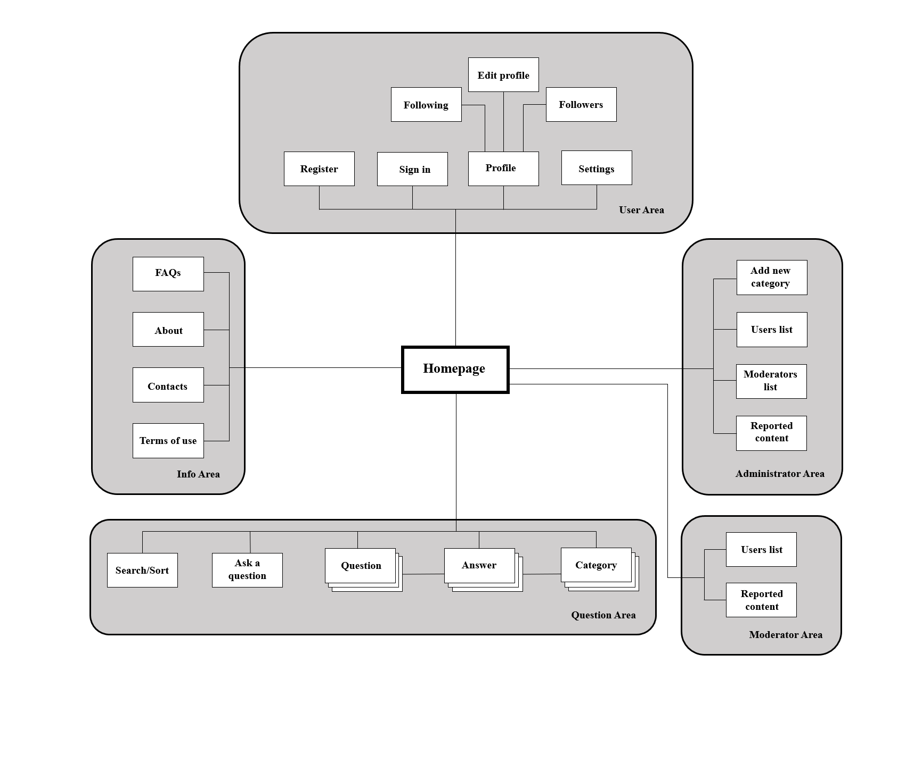A sitemap is a visual representation of the relationship between the different pages of a website that shows how all the information fits together. It gives the team an idea of how the website is going to be build by helping to clarify the information hierarchy. Below is the sitemap for **LearnIt**.

**Fig 2.** Sitemap.

## Storyboards

Storyboards are presented to represent some of the main interactions with the system using a sequence of interfaces and explaining how navigation is done between them.

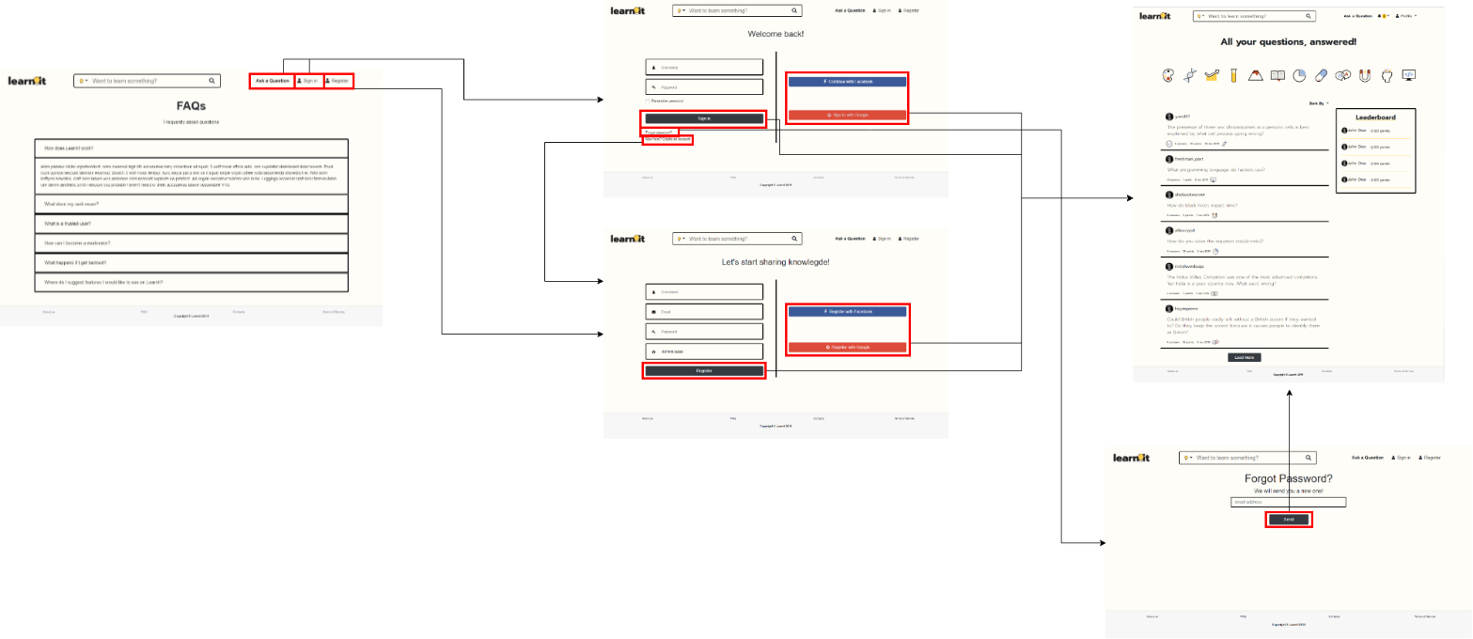**SB1: Sign in/ Register**

**Fig 3.** Wireflow for the sign-in and register interaction.

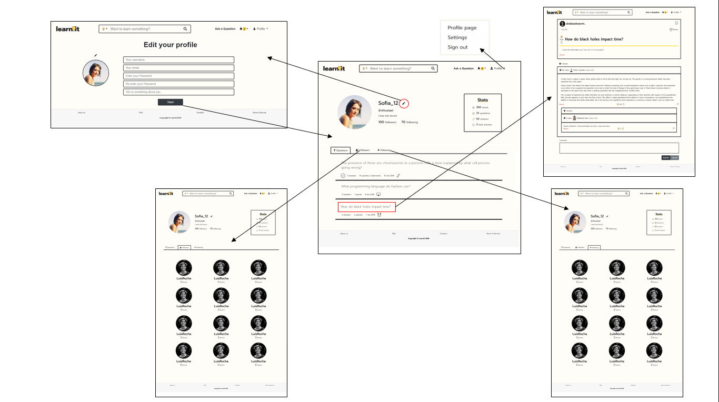**SB2: Profile**

**Fig 4**. Wireflow centred on user’s profile.

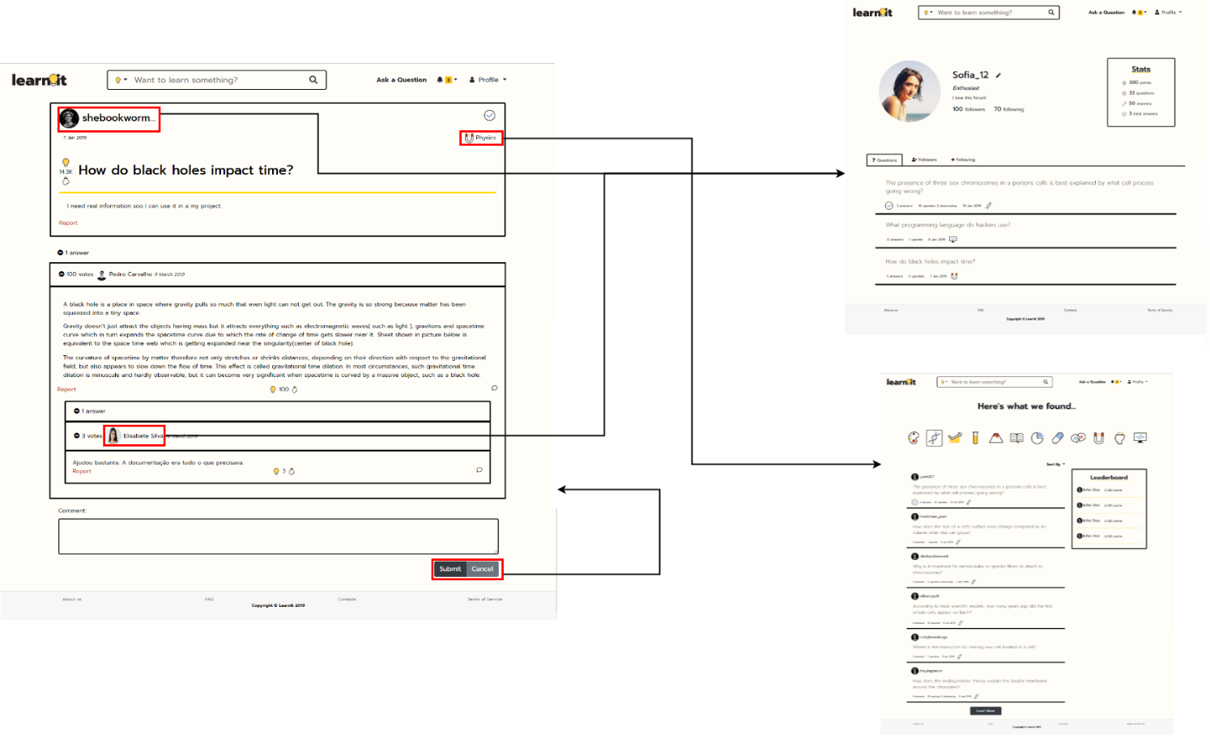**SB3: Question**

**Fig 5.** Wireflow centered on questions.

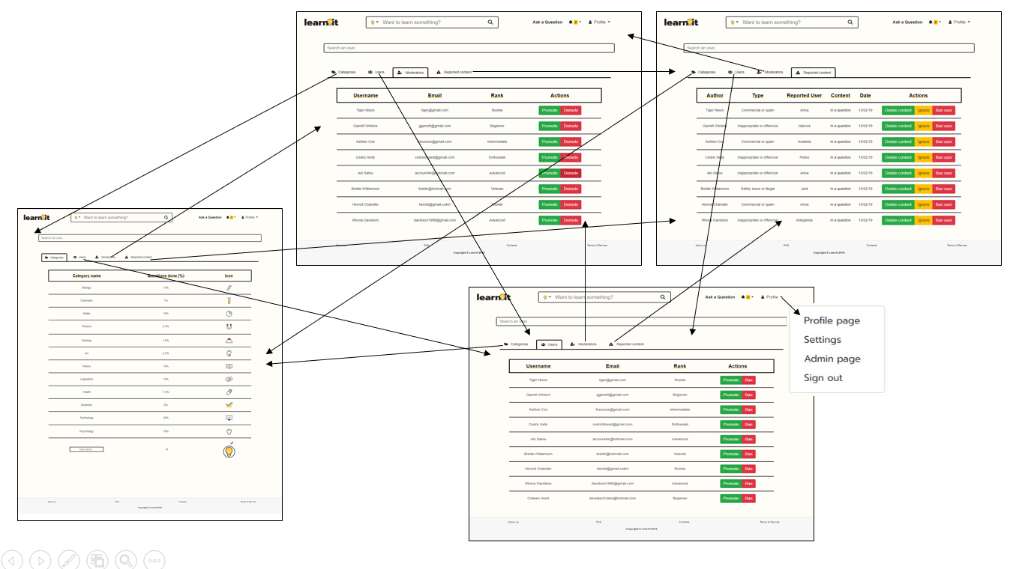**SB4: Admin area**

**Fig 6.** Wireflow centered on the admin’s options.

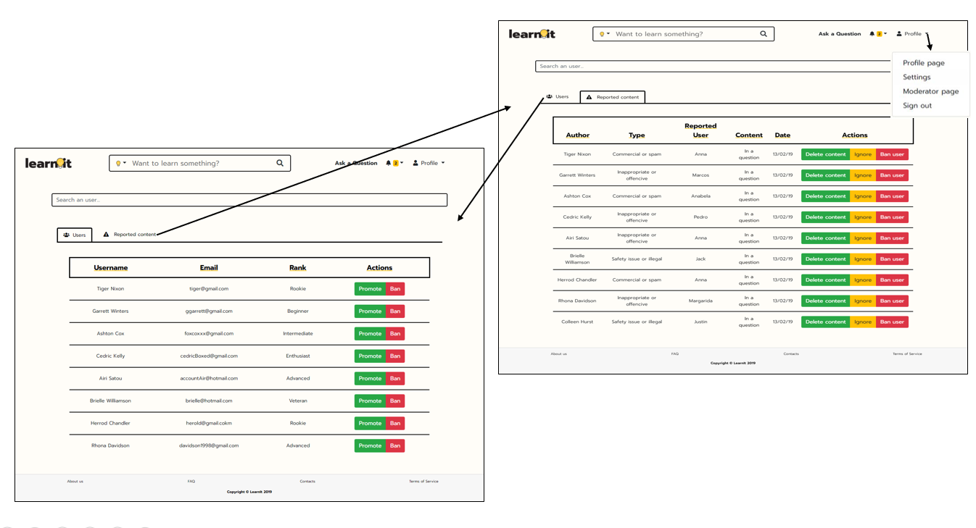**SB5: Moderator area**

**Fig 7.** Wireflow centered on the moderators’s options.

## Interfaces

The following interfaces describe the main content of the web pages and their relative priority, helping the team preview the features and behaviour of the final product's different screens.

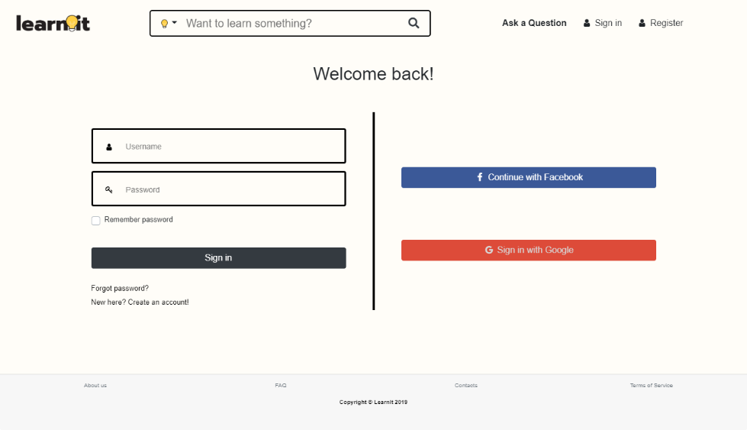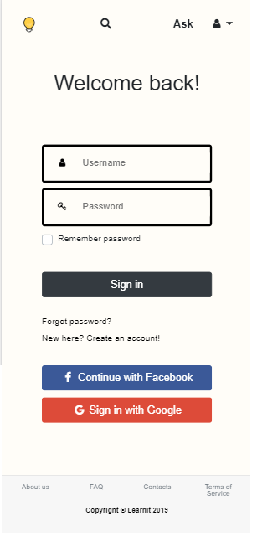**UI01: Sign in**

**Fig 8.** Sign in page, where users can authenticate.

**Link:** http://lbaw1834-piu.lbaw-prod.fe.up.pt/pages/login.html

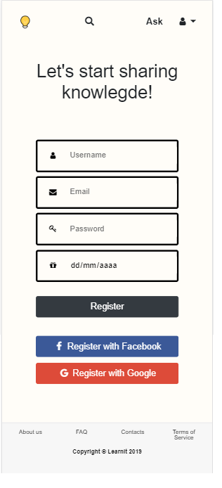**UI02: Register**

**Fig 9.** Sign up page, where users can register.

**Link:** http://lbaw1834-piu.lbaw-prod.fe.up.pt/pages/register.html

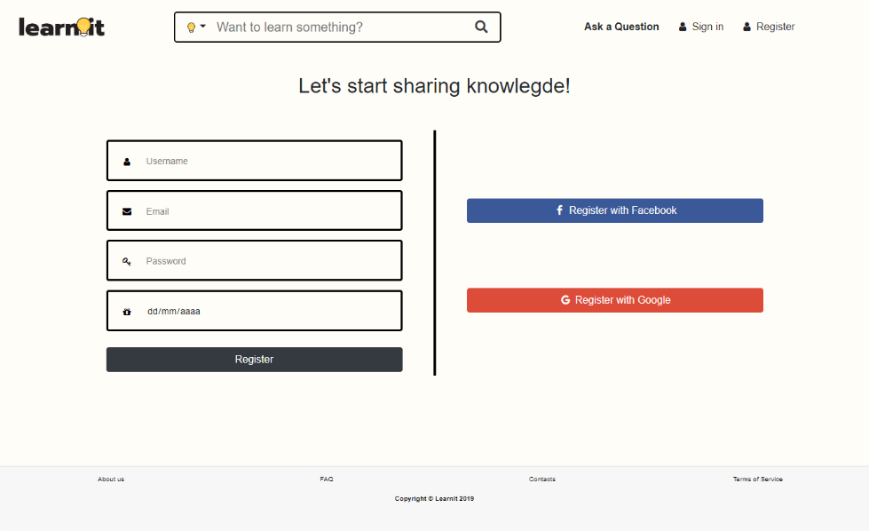

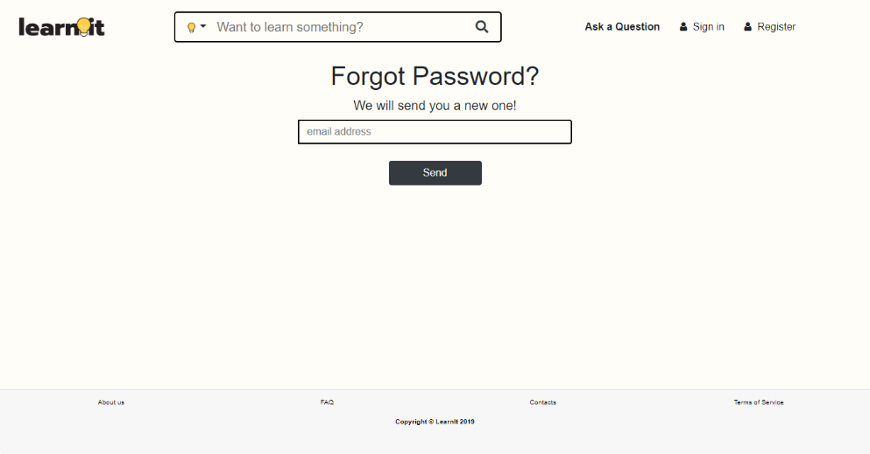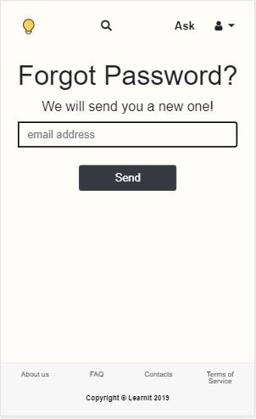**UI03: Recover password**

**Fig 10.** Recover password page, where users can recover their password.

**Link:** http://lbaw1834-piu.lbaw-prod.fe.up.pt/pages/recoverPassword.html

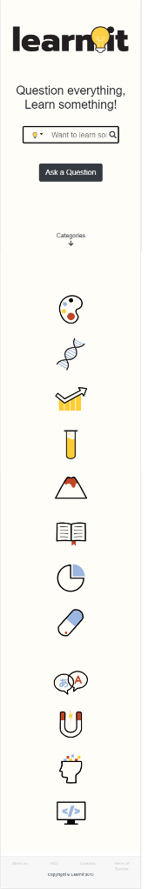**UI04: Home**

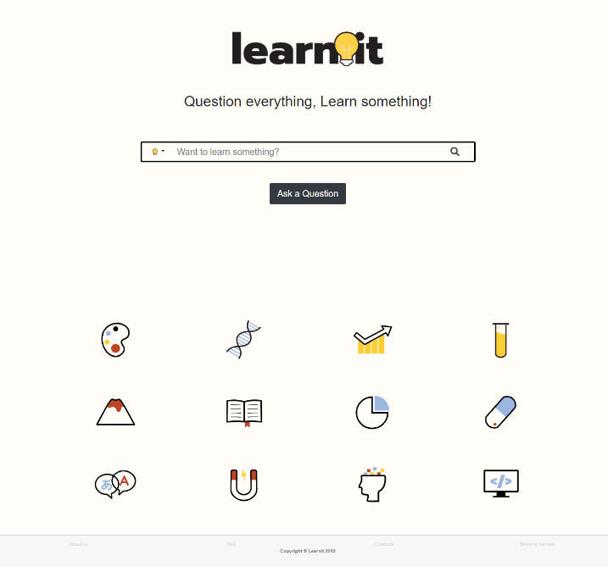

**Fig 11.** Home page, initial system’s page.

**Link:** http://lbaw1834-piu.lbaw-prod.fe.up.pt/pages/home.html

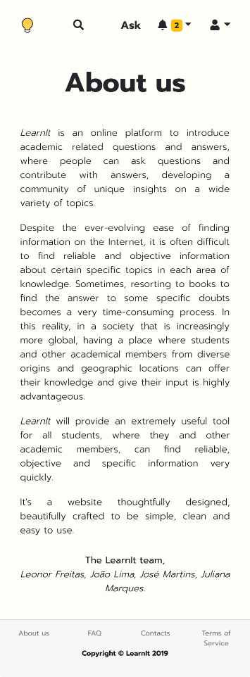**UI05: About**

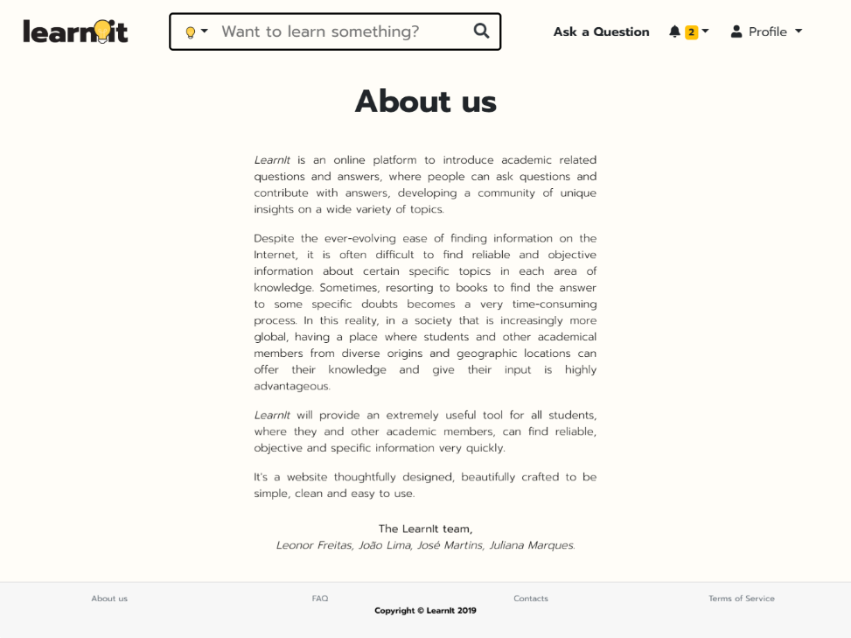

**Fig.** About page, where users can learn more about the website.

Link:

**Fig 12.** About page, where users can learn more about the website.

**Link:** http://lbaw1834-piu.lbaw-prod.fe.up.pt/pages/about.html

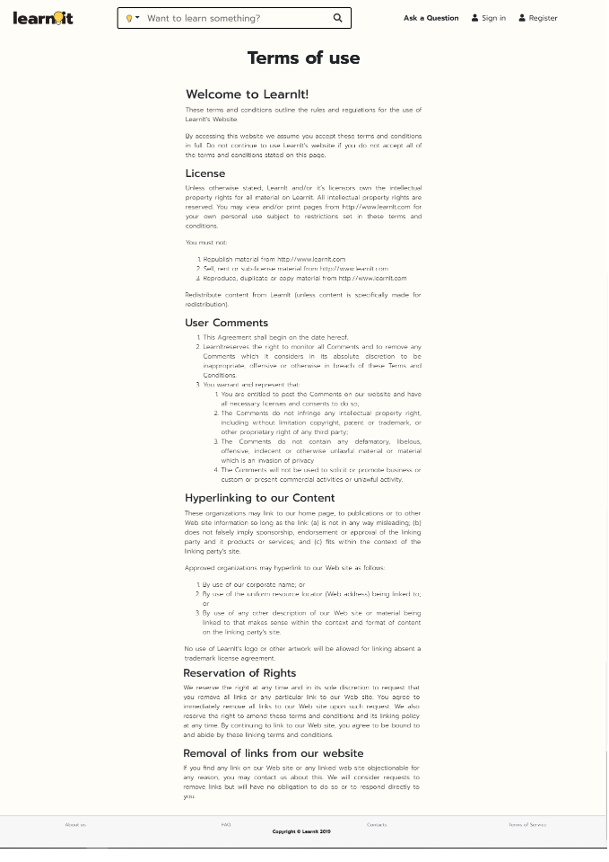**UI06: Terms of use**

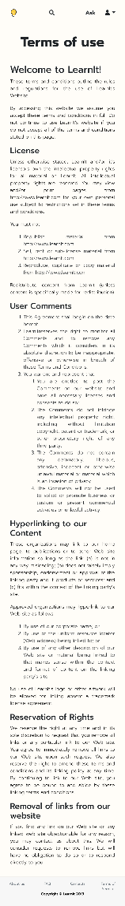

**Fig 13.** Terms of use page, where users can learn more about the terms of use of the website.

**Link:** http://lbaw1834-piu.lbaw-prod.fe.up.pt/pages/terms.html

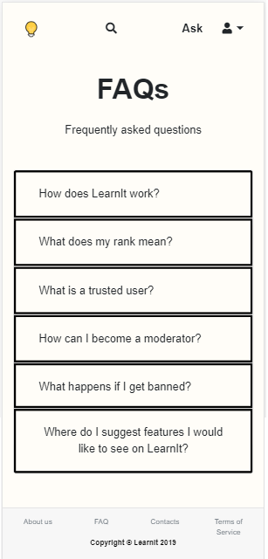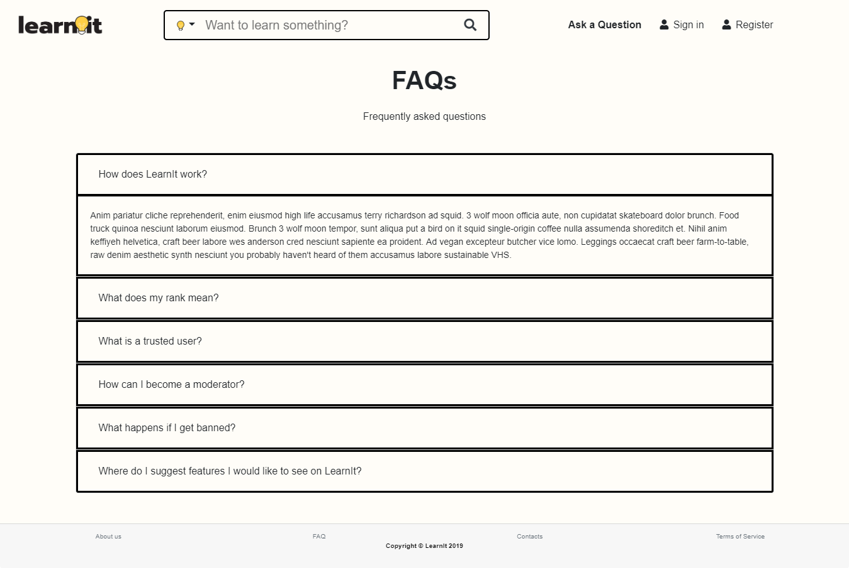**UI07: FAQs**

**Fig 14.** Frequently asked questions page, where users can obtain frequently enquired information about the website.

**Link:** http://lbaw1834-piu.lbaw-prod.fe.up.pt/pages/faq.html

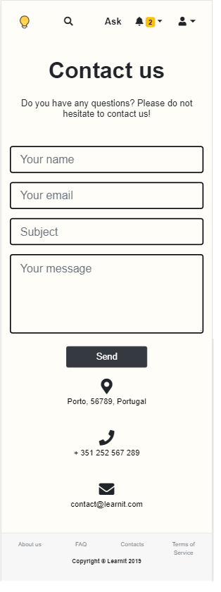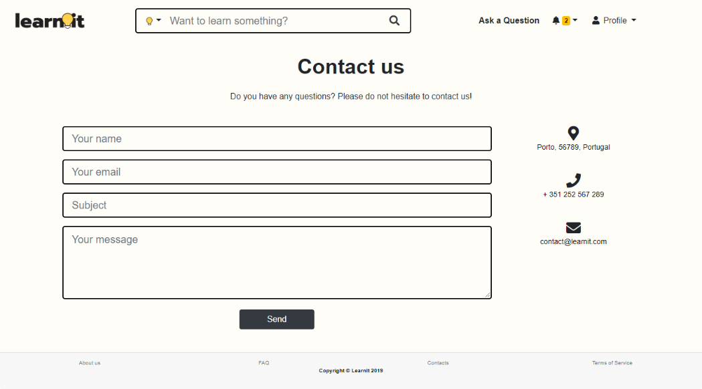**UI08: Contacts**

**Fig 15.** Contacts page, where users can ask questions, make suggestions or complain about the service.

**Link:** http://lbaw1834-piu.lbaw-prod.fe.up.pt/pages/contacts.html

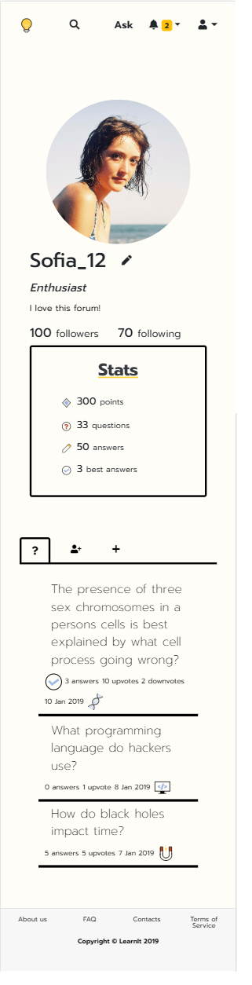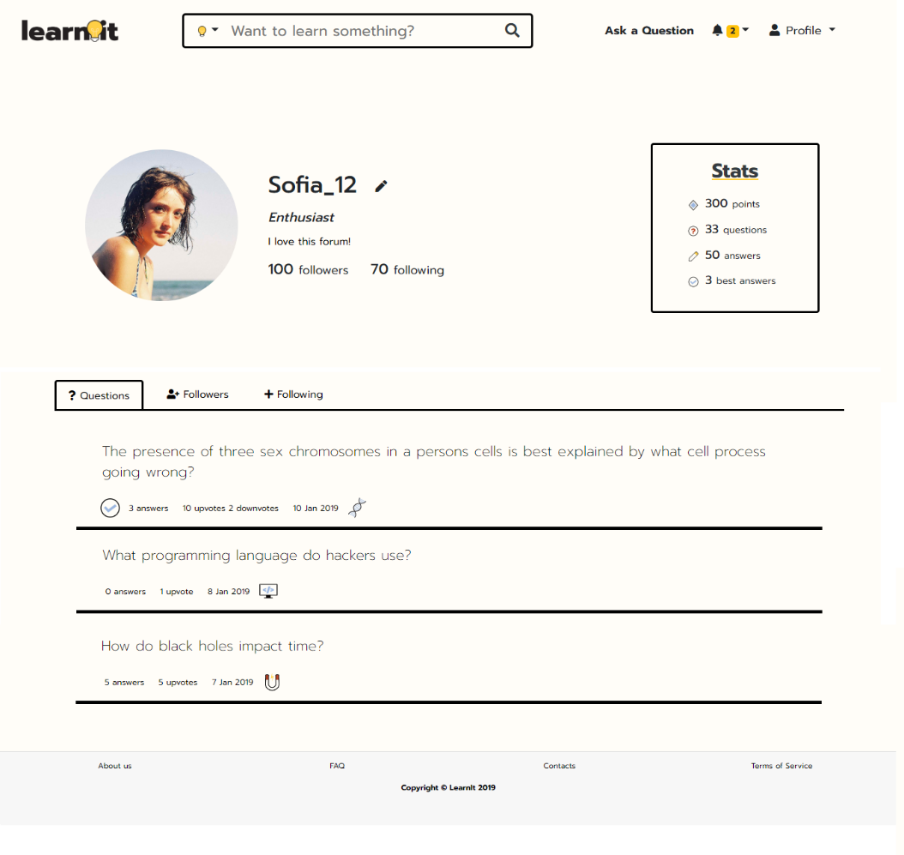**UI09: Profile**

**Fig 16.** Profile page with asked questions, where users can can obtain all the public information about they.

**Link:** http://lbaw1834-piu.lbaw-prod.fe.up.pt/pages/profile.html

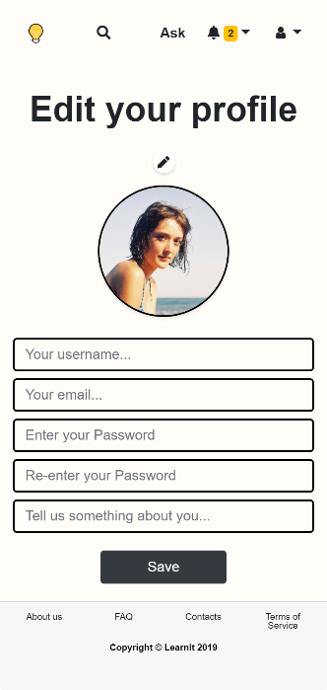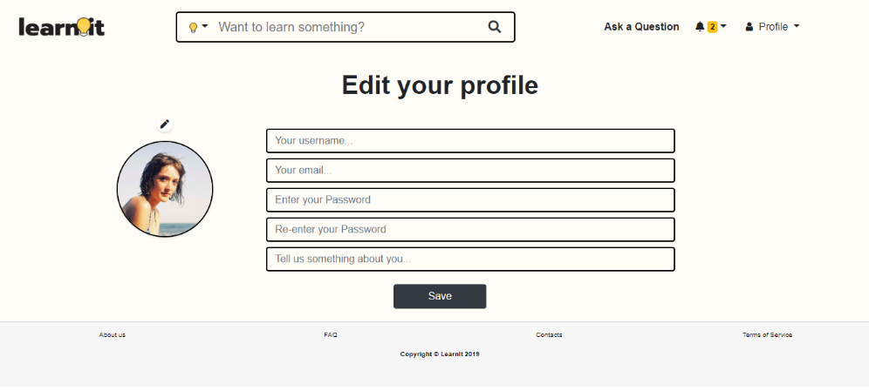**UI10: Edit profile**

**Fig 17.** Edit Profile page, where members can update their account’s information.

**Link:** http://lbaw1834-piu.lbaw-prod.fe.up.pt/pages/edit_profile.html

**UI11: Following / Followers**

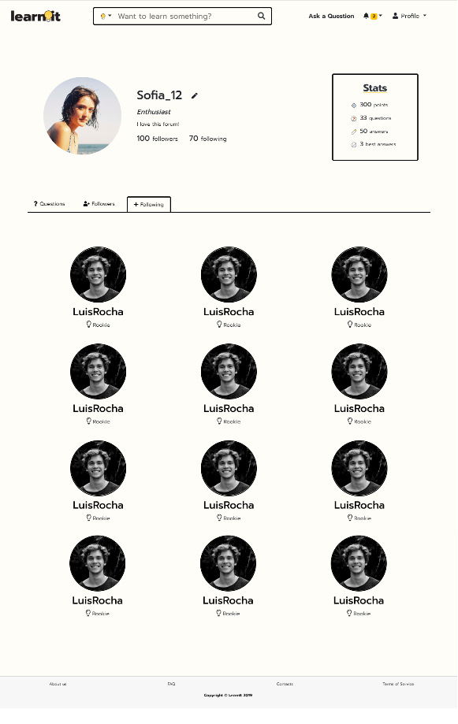

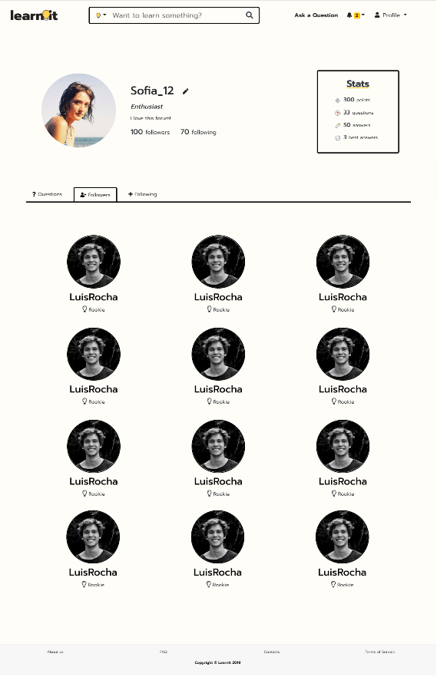

**Fig 18.** Followers/Followings page, where users can check who follows them and who they follow.

**Link:** http://lbaw1834-piu.lbaw-prod.fe.up.pt/pages/profile.html

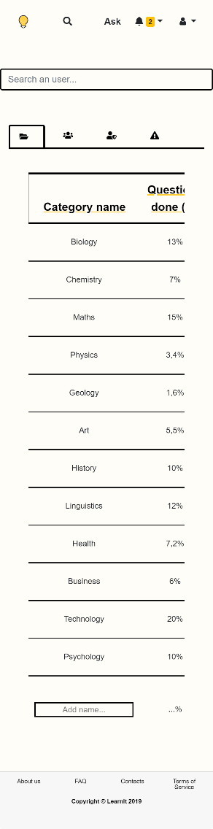**UI12: Admin – add category**

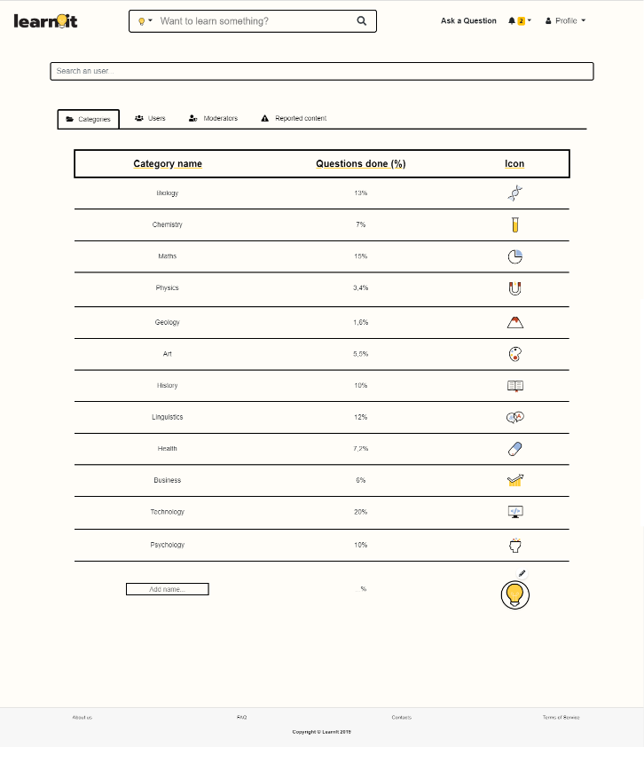

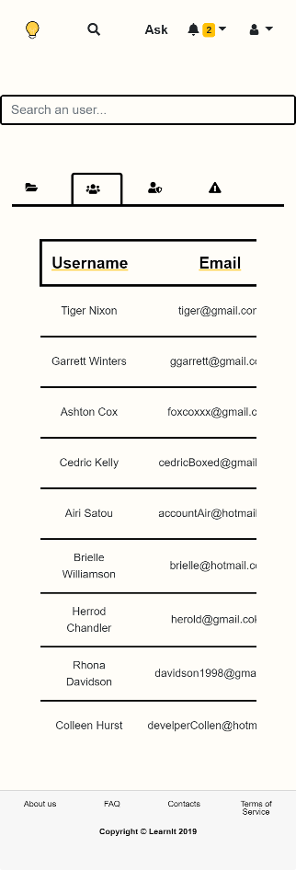

**UI13: Admin – users**

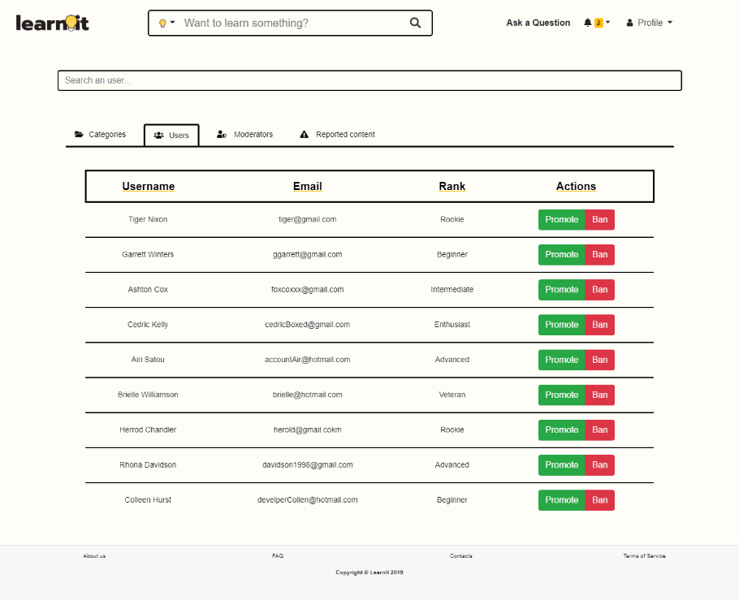

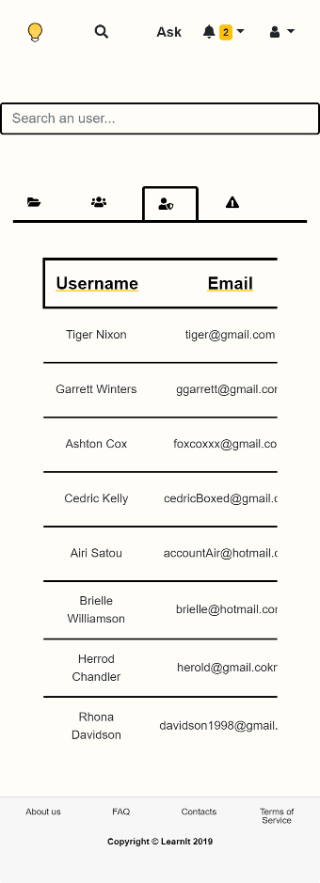**UI14: Admin – moderators**

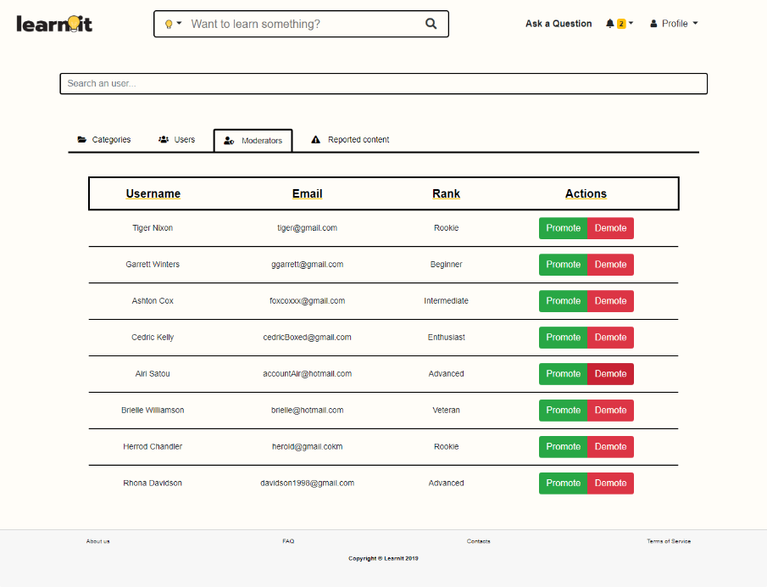

**UI15: Admin – reported content**

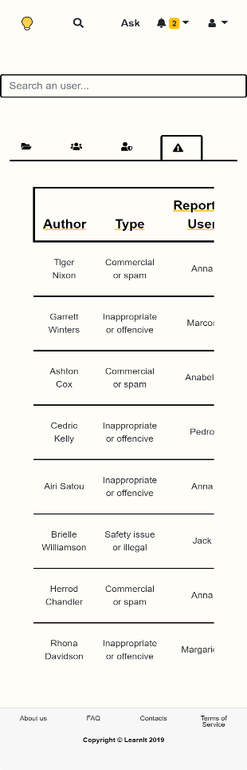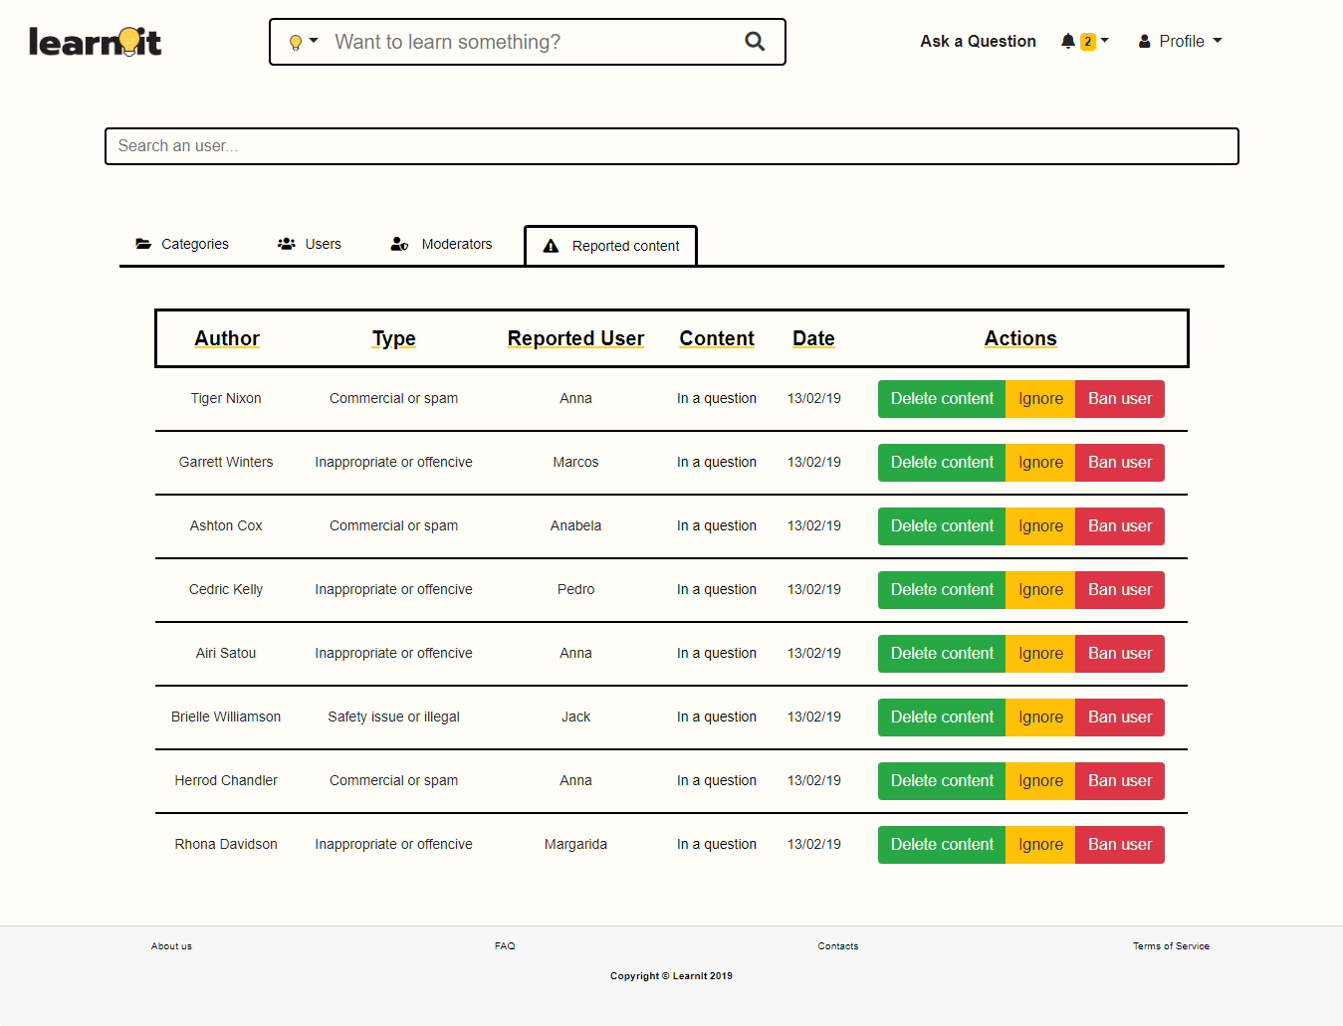

**Fig 19.** Administration page, where the admin can manage all the users and moderators.

**Link:** http://lbaw1834-piu.lbaw-prod.fe.up.pt/pages/admin.html

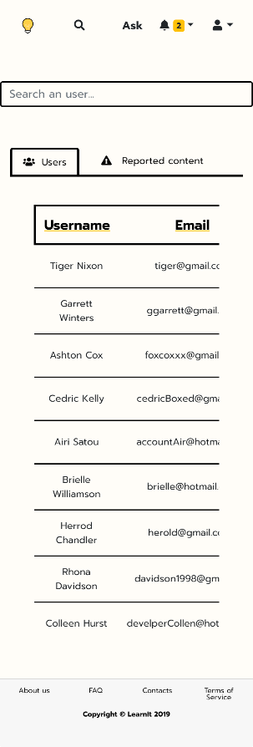**UI16: Moderator – users**

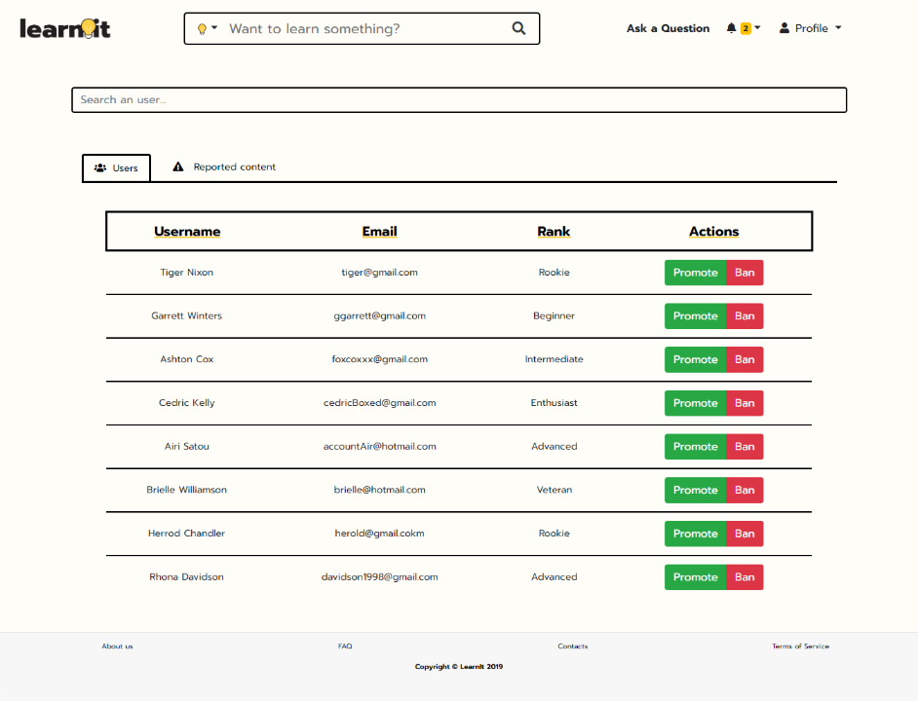

**UI17: Moderator – reported content**

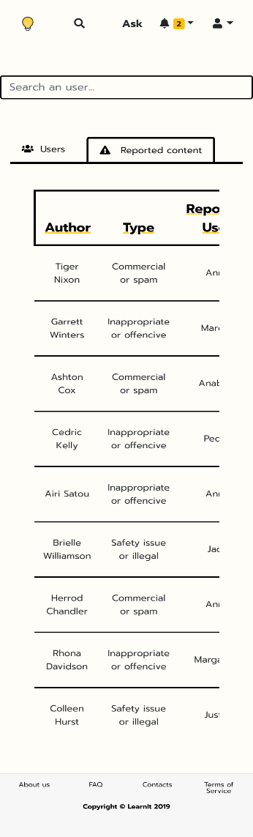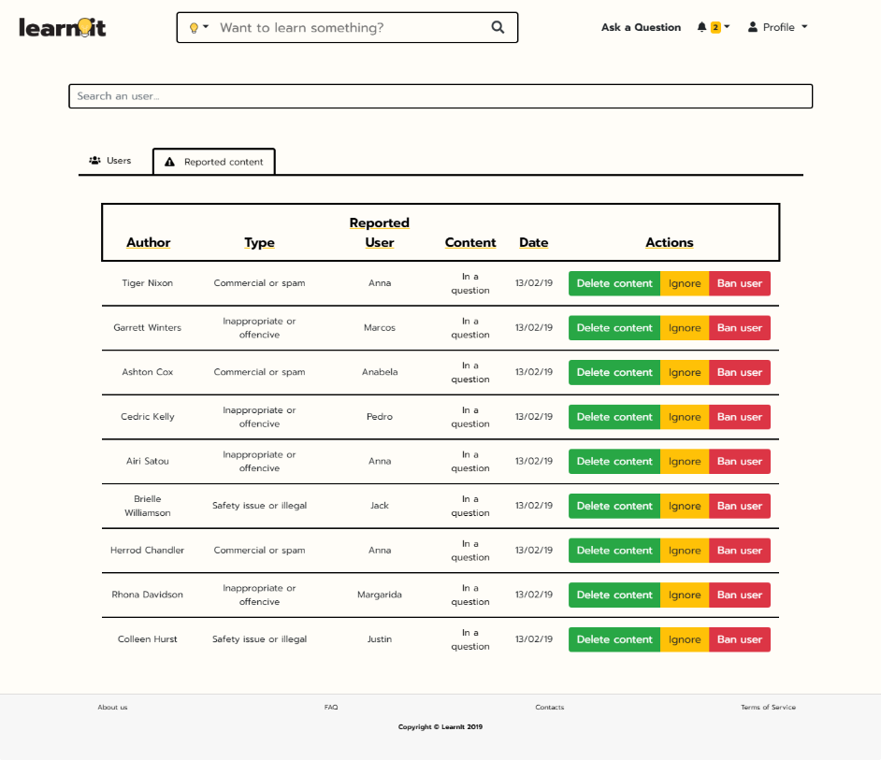

**Fig 20.** Moderators page, where the moderators can manage all the users.

**Link:** http://lbaw1834-piu.lbaw-prod.fe.up.pt/pages/moderator.html

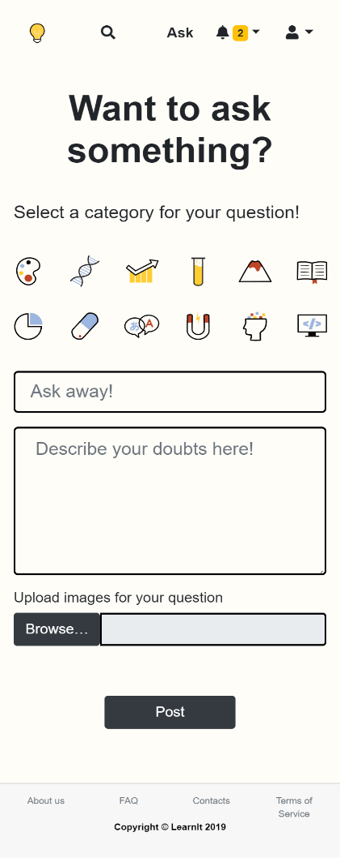**UI18: Ask a question**

**Fig 21.** Ask a question page, where users can ask their questions.

**Link:** http://lbaw1834-piu.lbaw-prod.fe.up.pt/pages/ask.html

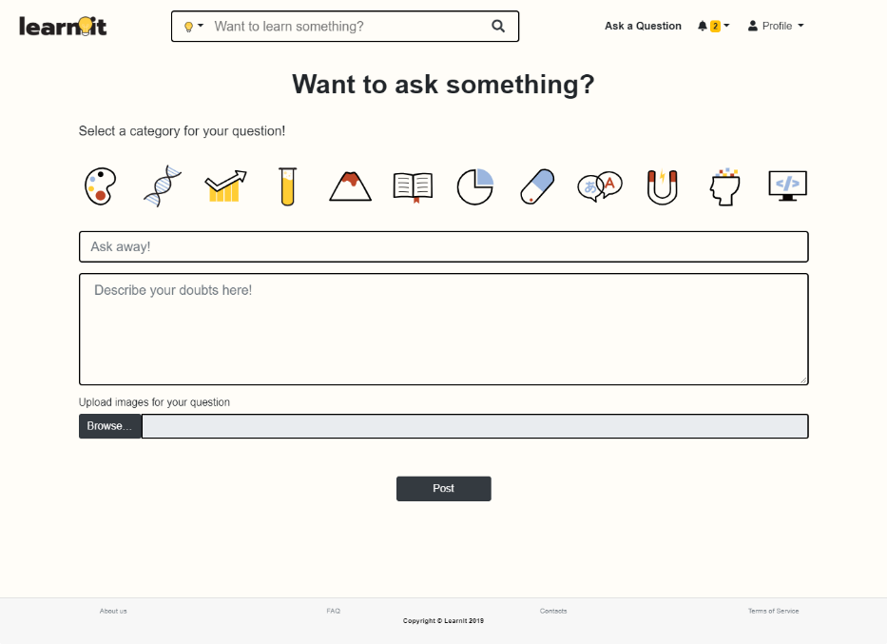

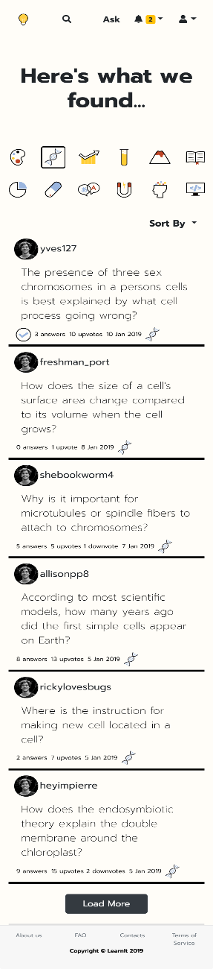**UI19: Topic (questions of a category)**

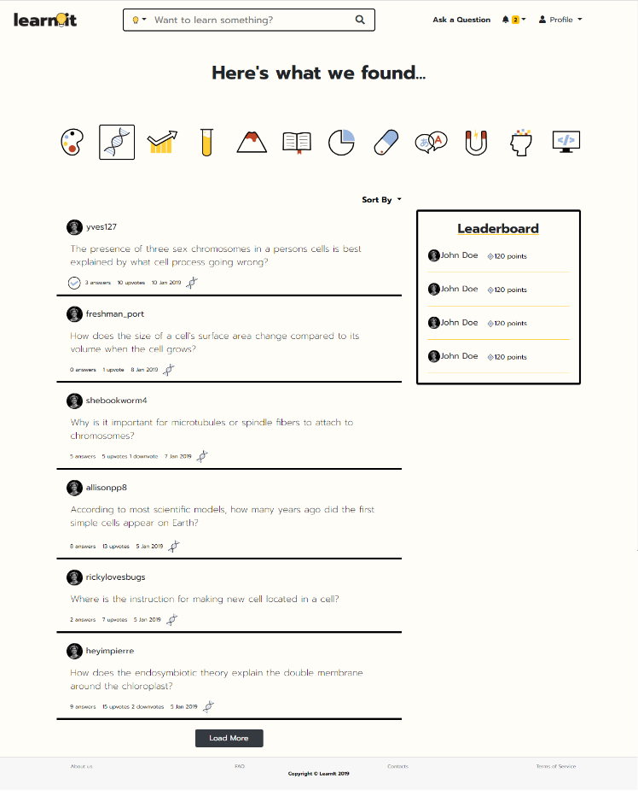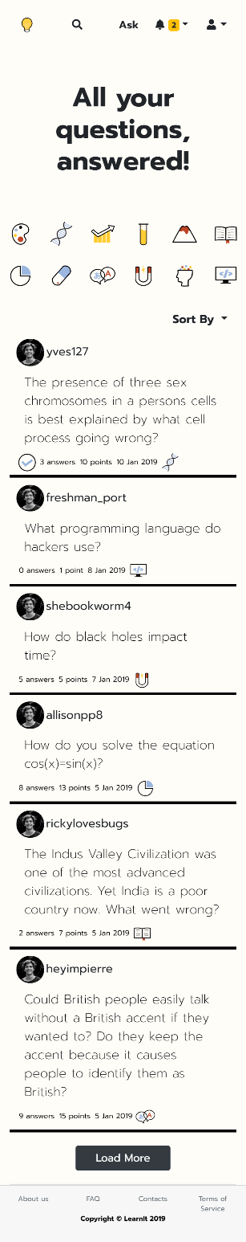**UI20: Feed**

**Fig 22.** Topic page, where a specific category’s history can be seen in detail.

**Link:** http://lbaw1834-piu.lbaw-prod.fe.up.pt/pages/topic.html

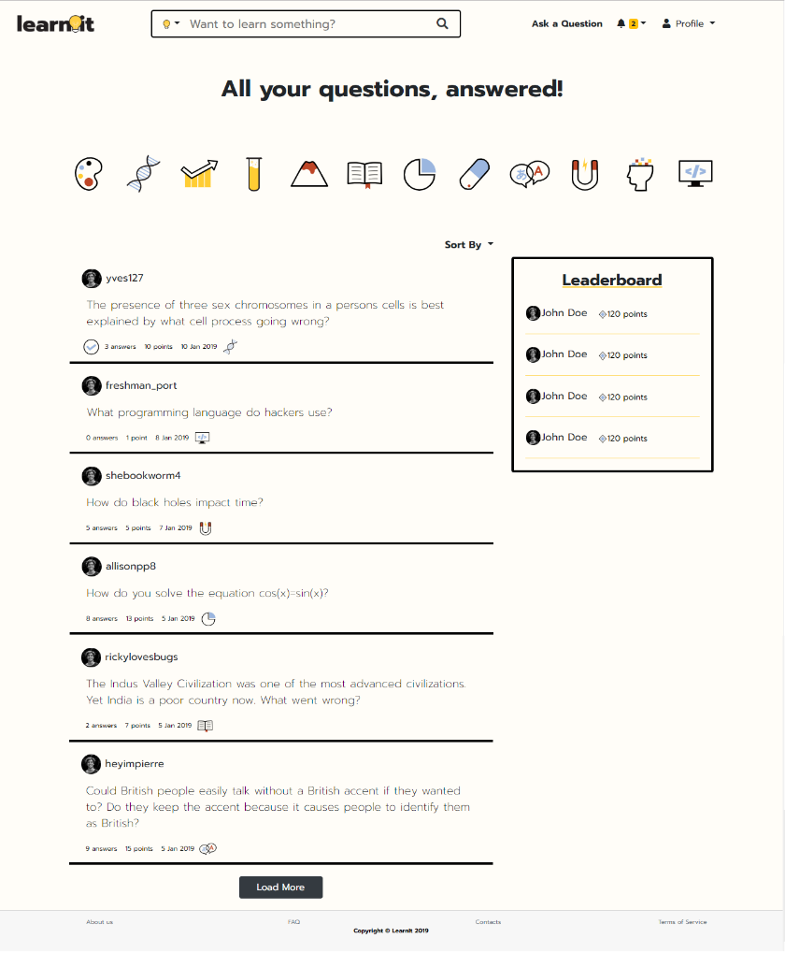

**Fig 23.** Feed page, where users can look up anything in the system.

**Link:** http://lbaw1834-piu.lbaw-prod.fe.up.pt/pages/feed.html

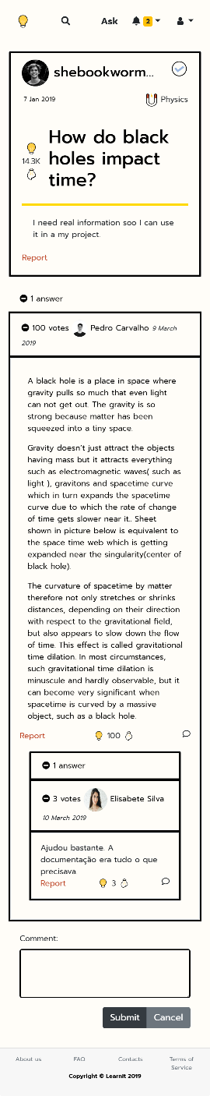**UI21: Question in detail**

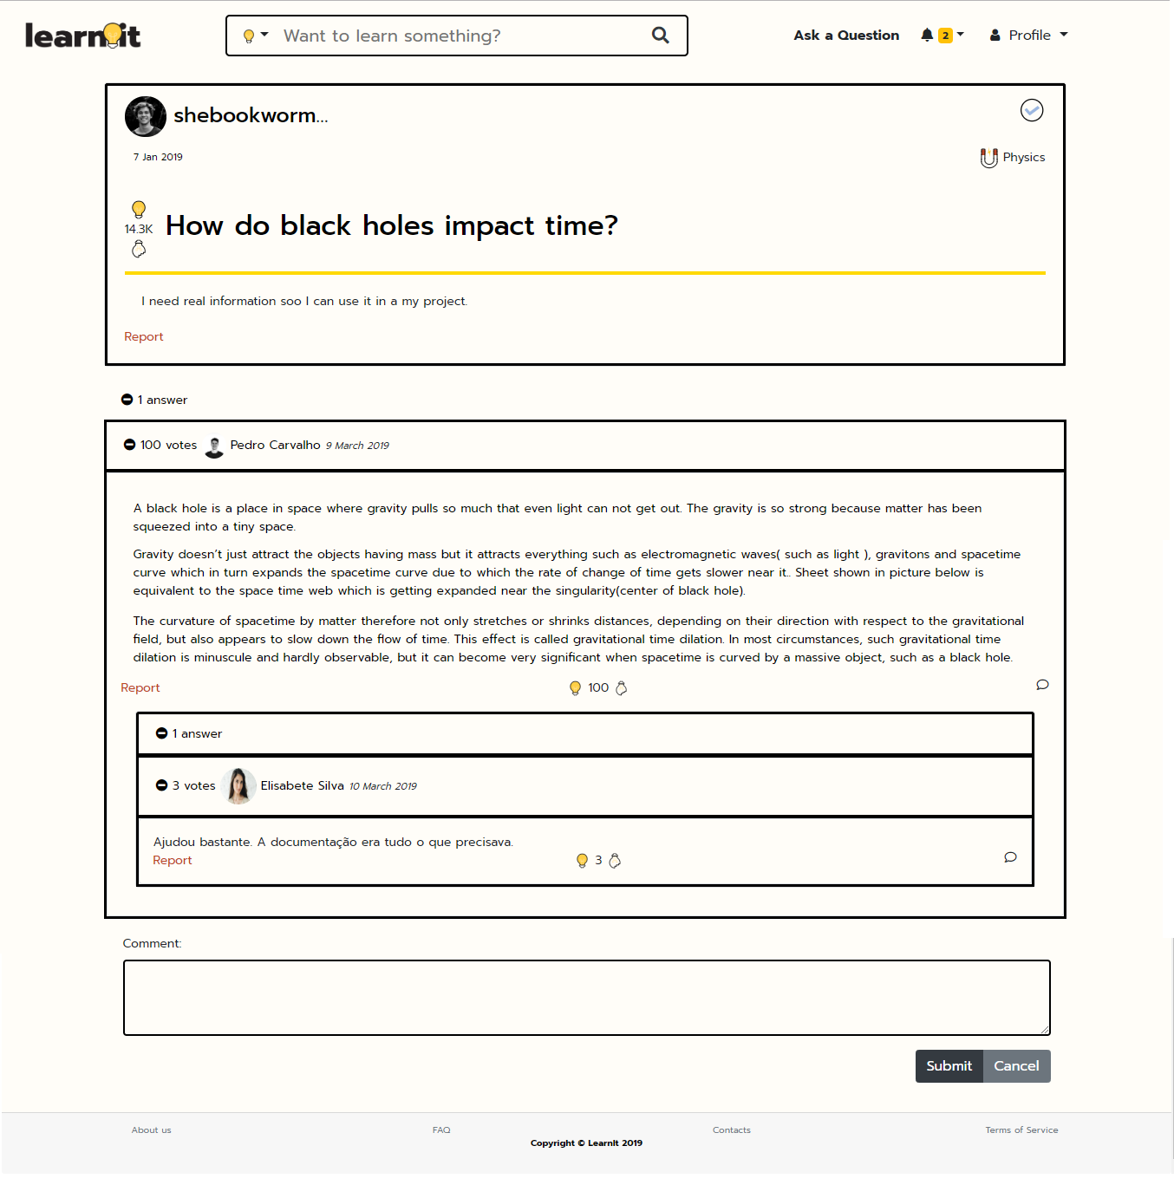

**Fig 24.** Question in detail page, where users can see answers, comments an also react to the question (vote/ answer).

**Link:** http://lbaw1834-piu.lbaw-prod.fe.up.pt/pages/questionDetail.html

**UI22: 404**

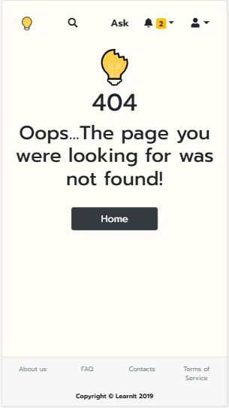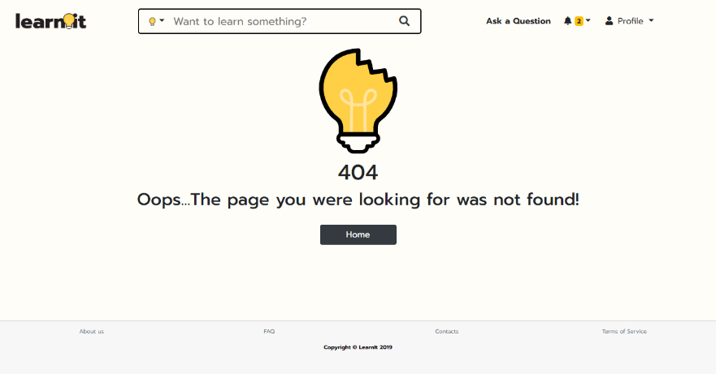

**Fig 25.** 404 page, the error page.

**Link:** http://lbaw1834-piu.lbaw-prod.fe.up.pt/pages/404.html

**UI23: Settings**

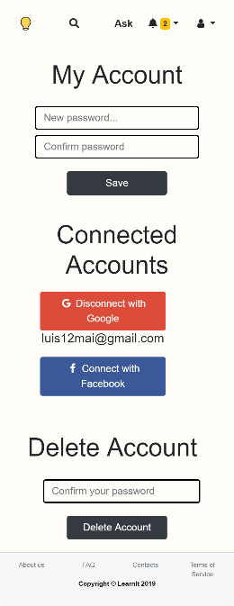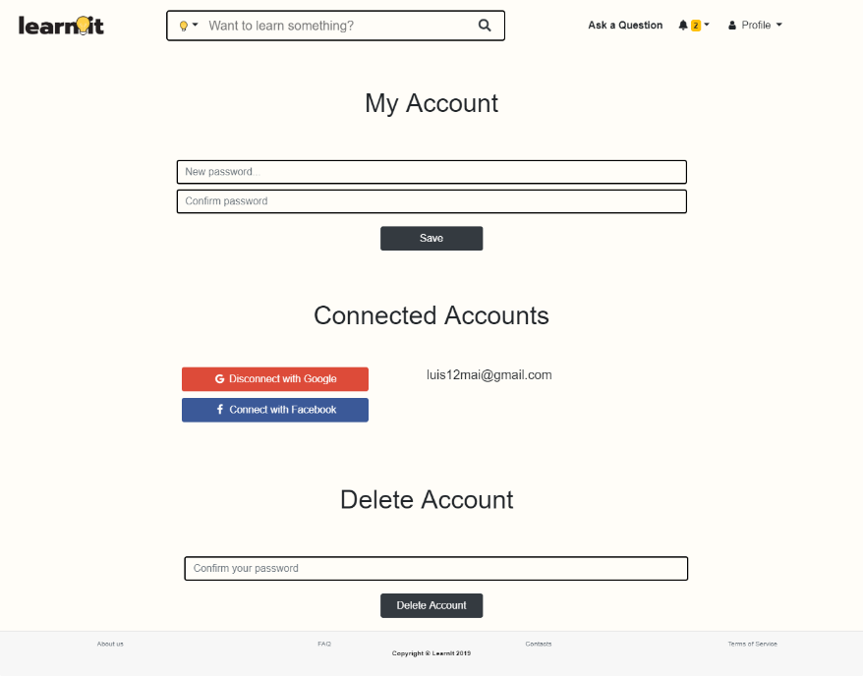

**Fig 26.** Settings page, where members can update their account’s details.

**Link:** http://lbaw1834-piu.lbaw-prod.fe.up.pt/pages/settings.html

## Group1834:

* João Augusto dos Santos Lima, up201605314@fe.up.pt
* José Diogo da Cunha Moreira Trindade Martins, up201504761@fe.up.pt
* Juliana Maria Cruz Marques, up201605568@fe.up.pt
* Leonor Ribeiro e Sousa Mendes de Freitas, up201207603@fe.up.pt